# 2004-NPcrestHori_B-W

# School of InfoComm Technology

**Data Exploration & Analysis Assignment**

Diploma in DS

April 2023 Semester

**ASSIGNMENT 2**

(40% of DEA Module)

10th July 2023 – 13th August 2023

**Submission Deadline:**

**Presentation: 13th August 2023 (Sunday), 11:59PM**

**Report and files: 13th August 2023 (Sunday), 11:59PM**

|  |  |  |
| --- | --- | --- |
| **Tutorial Group** | **:** | **T01 / T02 / T03** |
| **Student Name** | **:** |  |
| **Student Number** | **:** |  |

**Penalty for late submission:**

10% of the marks will be deducted every calendar day after the deadline.

**NO** submission will be accepted after 20th August 2023 (Sunday), 11:59PM.

**1. Assignment Overview**

A case study will be used to assess students based on their ability to apply the knowledge/skills gained from Data Exploration and Analysis (DEA) module to the Assignment.

Students will be given a detailed description of the company profile, sales and other related datasets where they will apply analytics using techniques learnt in DEA. The additional analysis from the student will serve to assist management in making appropriate sales and marketing decisions.

Based on the findings and trends discovered using analytical techniques, the student will provide recommendations to the management to improve business performance.

The student will then need to produce a report that contains a description of the above processes, critical analysis and make recommendations to the management to meet business objectives.

**2. Assignment Background**

Founded in 2020, ***TechScape Singapore*** is a leading technology company that specializes in providing a comprehensive range of electronics and smart solutions. From computers and smart devices to televisions and phones, TechScape offers a diverse portfolio of technologically advanced products that cater to various needs and preferences. They have branches in different parts of Singapore and are looking into expanding their business operations.

With the rapid growth of e-commerce and the increasing demand for hassle-free online shopping, TechScape recognizes the importance of adapting to the digital landscape. The launch of the online sales platform in 2021 reflects TechScape's commitment to meeting the evolving needs and preferences of its customers.

The CEO of TechScapehas decided to setup a Business Analytics team, which will provide Business Intelligence reports and analysis to assist the management in making decisions.

The IT department is exploring the possibility of setting up an Enterprise Data Warehouse (EDW) in order to have a central repository of the company’s sales data. Meanwhile, its various departments have consolidated their data into different CSV files. DataDictionary.csv provides a brief description of the fields used in each CSV file. You are to integrate the CSV files together and perform data modelling on the dataset given. Refer to appendix A for the table of various csv files. You are encouraged to create your own Calendar table.

Your task as a Business Analyst is to analyse the underlying data and create relevant and useful dashboards to aid managerial decision making using the given data in the CSV file. The management should be able to make use of the dashboards to identify critical patterns and trends to plan targeted campaigns to achieve the business objectives of the company.

**3. Assignment Tasks**

***Part 1: Creating dashboards to address business questions (70 Marks)***

You are to **create dashboards** using the dataset provided to allow stakeholders to answer the following questions to improve the company’s sales performance, product offerings, operations etc.

1. **Which period has the most Sales?** - To identify if there is any seasonality in sales as this will help to optimise management of inventories, staffing and timing of appropriate marketing campaigns.
2. **What are the Top 5 most popular products for the various sales channels?** - To identify the most appropriate target products for TechScapeto efficiently and effectively use marketing activities to engage customers.
3. **What are the Top & Bottom 5 branches in terms of profit[[1]](#footnote-1)?** - Monitoring the top and bottom 5 branches in terms of gross profit enables TechScapeto make informed decisions, optimize resources, drive improvement, and align its strategies to maximize overall sales and profitability.

You are to create at least **ONE more business question** with the rationale included, why this question is critical.

Design a dashboard to visualise TechScape data using **Power BI Desktop**. The dashboard should be able to highlight critical Key Performance Indicators (KPIs) to address all the business questions above. Dashboard best practices must be applied when designing the dashboard.

Write a **report section** (maximum of 2,000 words with appropriate visualisation) to detail the step-by-step approach in completing the tasks in **Part 1**. You can also elaborate on the rationale behind their choices in performing the tasks above. State clearly all the additional DAX measures, columns and their corresponding formulas used.

***Part 2: Further Analytics (30 marks)***

Perform further analytics using appropriate advanced analytical techniques (e.g. univariate, bivariate, multivariate analysis, Pivot Tables, Data Mining, etc.). For example, is there a particular product that shows significant clusters towards a certain geographical locality or purchasing mode of the customers? Identify any critical trend(s) to help the company improve its business performance based on advanced analytical results.

Write a **report section** (maximum of 2,000 words with appropriate visualisation) to detail the step-by-step approach in completing the task in **Part 2**. You are to elaborate on the rationale behind their choices in performing task, and how that can bring more insights on understanding the business better.

|  |  |  |
| --- | --- | --- |
|  | **Suggested Report Sections & Content Guidelines** | **Word Count** |
| 1. | Table of Contents | NA |
| 2. | Abstract/Overview | Max: 500 words |
| 3. | Creating dashboard to answer business question (for Part 1) | Min: 1000 words  Max: 2000 words |
| 4. | Further analysis (for Part 2) | Max: 2000 words |
| 5. | Summary   * Summarize your findings * Reflections on Data modeling, Data exploration and Analysis process | Min: 500 words  Max: 1000 words |

**4. Assignment Deliverables**

***Files submission***

Each student is required to submit all the required solution files in the assignment submission folder in POLITEMall. Before submission to POLITEMall, please ensure that the solution files are in a single folder.

Zip all the files in the folder and name the zipped folder as **[student\_name]\_[student\_ID].zip.** Submit the zip file to POLITEMall in Assignment 2 Submission by **13th August 2023 (Sunday), 11:59pm.**

***Video Presentation***

This video assignment app, powered by Bongo, allows students to capture their presentations multiple times and finally choose their best presentation to be submitted. Each student is to practice the presentation in advance to ensure completion **within 10 minutes**. The recording must include both webcam (clearly showing the student's face for authentication) and slides or codes (whichever is applicable).

Select the **RECORD VIDEO** option and choose **CAMERA + SCREEN** as shown in the figure below. The figure may differ with the constantly update of the Bongo software, hence students may see a different layout but general steps should still apply.

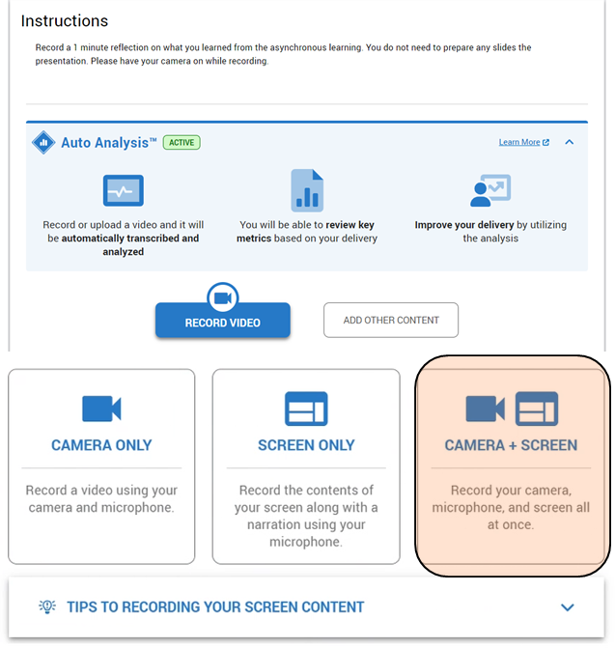

After recording the video, click save (as shown below) and it will be ready for students to append it for submission.



Select the video by clicking on the Star and click **SUBMIT**.

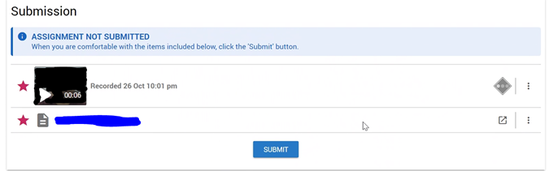

**End of Document**

**Appendix A (Datasets)**

|  |  |
| --- | --- |
| **Fields** | **Definitions** |
| Channel.csv | Different methods of purchases |
| Geography | Location of the various branches |
| Products | List of all products sold. |
| ProductCategory | List of product categories |
| ProductSubCategory | List of product sub-categories |
| Promotions | List of all promotions launched by company |
| Sale | Sales Fact table by finance department |
| Stores | Details of all the stores, names and area. |

**Appendix B (Assessment Rubrics)**

|  |  |  |
| --- | --- | --- |
| Section | Assessment Criteria | Marks |
| 1 | Dashboard Quality  Assessed based on:   * + Quality of visualization design   + Use of appropriate charts/table   + Dashboard and visualization interactivity (such as filters, slices, drill up/down)   + Clear concise visualization goals with the use of appropriate data for visualization | 30 |
| Report Quality  Assessed based on:   * + Clear and concise business definition.   + Data modelling and preparation process   + Data analysis   + Insights and Conclusion | 20 |
| Presentation  Assessed based on:   * + Clear, concise, and well-organized presentation   + Clear understanding of work done   + Meeting typical video presentation norms (video on, adequate sound level, etc.) | 20 |
| 2 | Report  Assessed based on:   * + Clear and concise problem statement and approaches used in analysis.   + Clear understanding of univariate, bivariate and multivariate analysis.   + Clear understanding in time-series analysis and data mining techniques   + Clear description of insights and conclusion | 20 |
| Presentation  Assessed based on:   * + Clear, concise, and well-organized presentation   + Clear understanding of work done   + Meeting typical video presentation norms (video on, adequate sound level, etc.) | 10 |

1. Profit = Sale Amount – TotalCost [↑](#footnote-ref-1)